Wexford County Historical Museum

Cadillac Carnegie Library
2021

Window Restoration Project

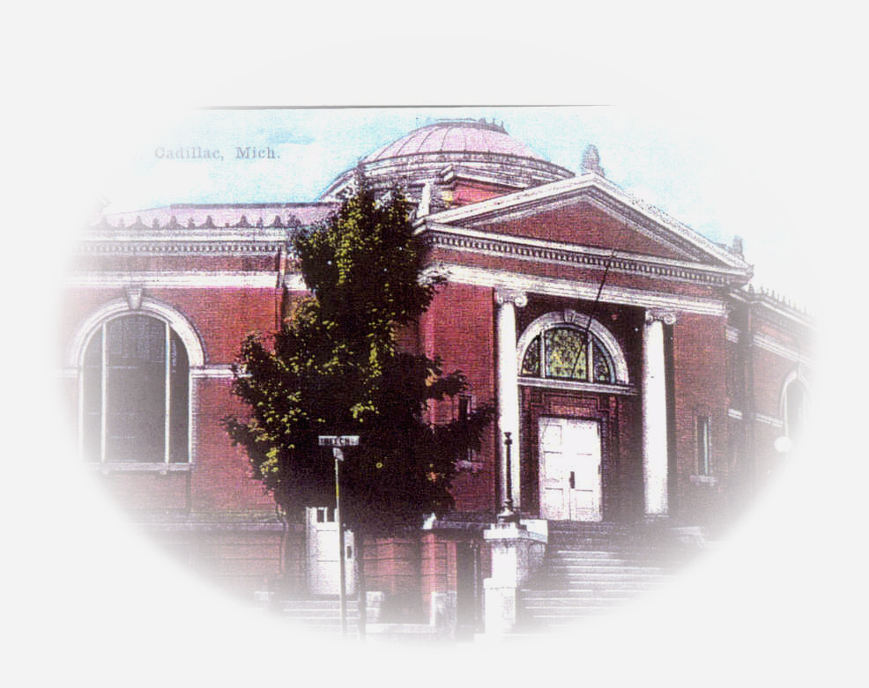

Preserving Our Past
♣

Serving Our Present Community
♣
Ensuring a community Landmark’s Future

WE NEED YOUR HELP! ANY AMOUNT! WON’T YOU JOIN US!
BUY A WINDOW
$20,000/Arched Please Circle choice
$10,000/Half-Arch mail check or Pledge intent
$3000/Circle WCHS
$2000 DOUble Hung PO Box 124
$1000 / $500 / $250 / Other _________ Cadillac, MI 49601

Happy to Have You thank You Ad in Cadillac News & on Facebook! Please call if you have any questions 231-920-9739

